**Week-1 Assignment Core Java**

1. **Given:**

**public class TaxUtil {**

**double rate = 0.15;**

**public double calculateTax(double amount) {**

**return amount * rate;**

**}**

**}**

**Would you consider the method calculateTax() a 'pure function'? Why or why not?**

**If you claim the method is NOT a pure function, please suggest a way to make it pure.**

The above function is not a pure function. A pure function always produces the same output for the same input. In the example above, the function takes a mutable value rate, changing rate would give different outputs to the same output.

To make the function a pure function we would make the following changes.

**public class TaxUtil {**

**public double calculateTax(double amount, double rate) {**

**return amount * rate;**

**}**

**}**

1. **What will be the output for following code?**

**class Super**

**{**

**static void show()**

**{**

**System.out.println("super class show method");**

**}**

**static class StaticMethods**

**{**

**void show()**

**{**

**System.out.println("sub class show method");**

**}**

**}**

**public static void main(String[]args)**

**{**

**Super.show();**

**new Super.StaticMethods().show();**

**}**

**}**

super class show method

sub class show method

**3) What will be the output for the following code?**

**class Super**

**{**

**int num=20;**

**public void display()**

**{**

**System.out.println("super class method");**

**}**

**}**

**public class ThisUse extends Super**

**{**

**int num;**

**public ThisUse(int num)**

**{**

**this.num=num;**

**}**

**public void display()**

**{**

**System.out.println("display method");**

**}**

**public void Show()**

**{**

**this.display();**

**display();**

**System.out.println(this.num);**

**System.out.println(num);**

**}**

**public static void main(String[]args)**

**{**

**ThisUse o=new ThisUse(10);**

**o.show();**

**}**

**}**

There is a small error, must be when the question was typed, the method show got a capital letter, while the method being called is lowercase, if it was intentional then the result is an error. If not then the output will be

display method

display method

10

10

**4) What is the singleton design pattern? Explain with a coding example.**

A singleton design pattern is a pattern where a class has only one instance and provides a global point of access to that instance.

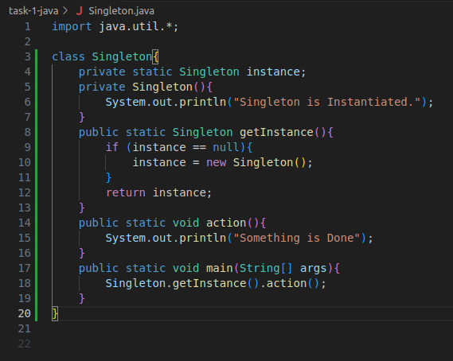

**Output –**

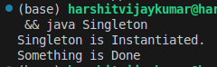

**5) How do we make sure a class is encapsulated? Explain with a coding example.**

To ensure a class is encapsulated:

1. Declare instance variables as private.
2. Provide public getter and setter methods.

Encapsulation is based on hiding data and allowing controlled access to the internal state of an object; this enhances maintainability, flexibility, and security of the code.

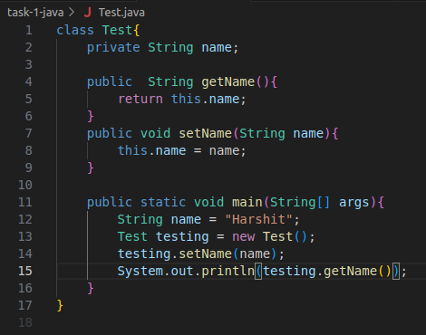

**Output –**



**6) Perform CRUD operation using ArrayList collection in an EmployeeCRUD class for the below Employee**

**class Employee{**

**private int id;**

**private String name;**

**private String department;**

**}**

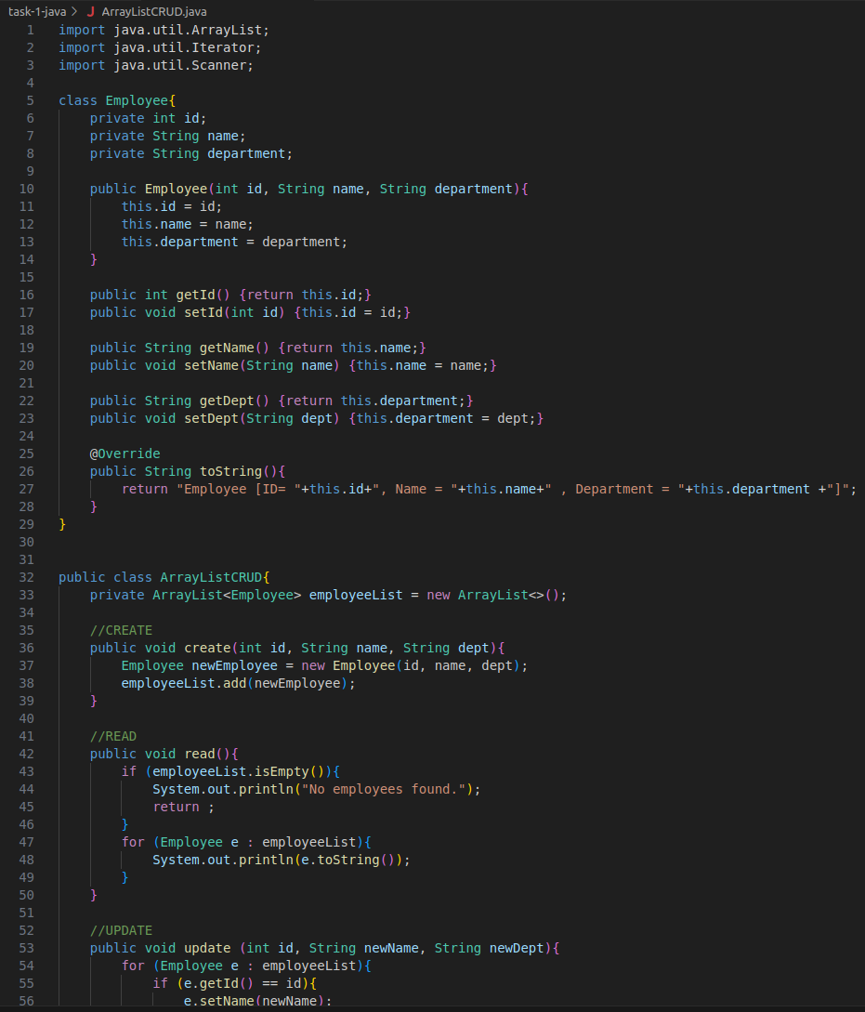

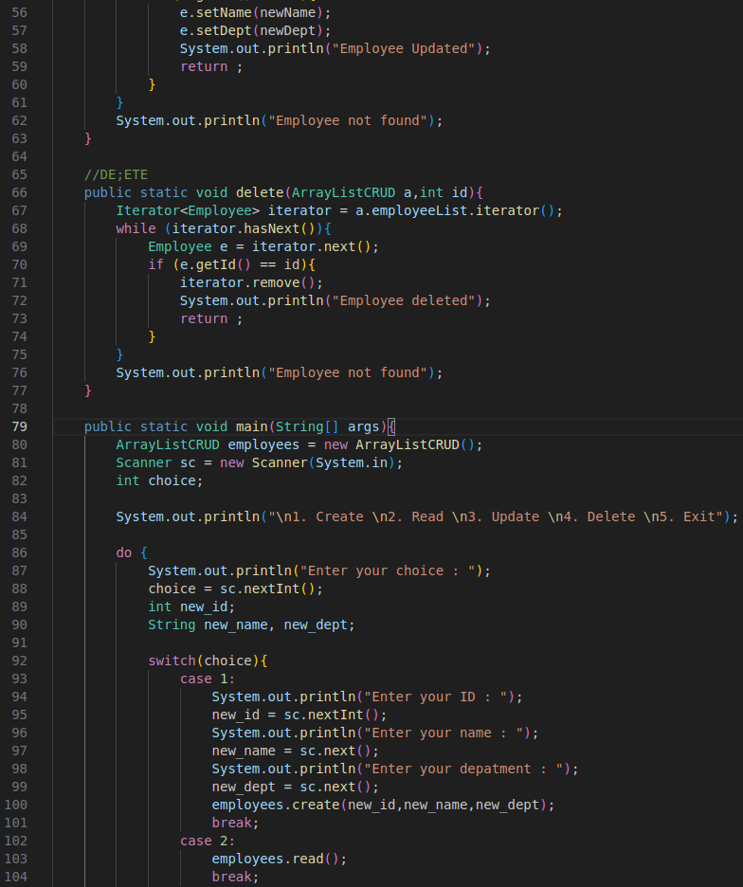

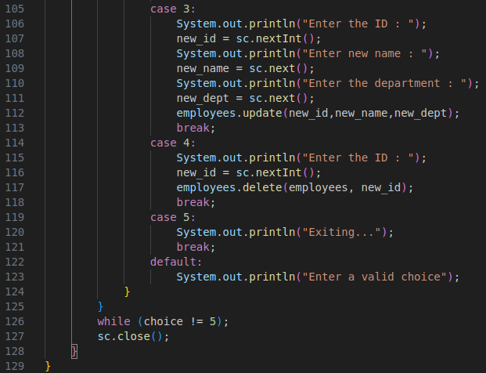



**Output –**

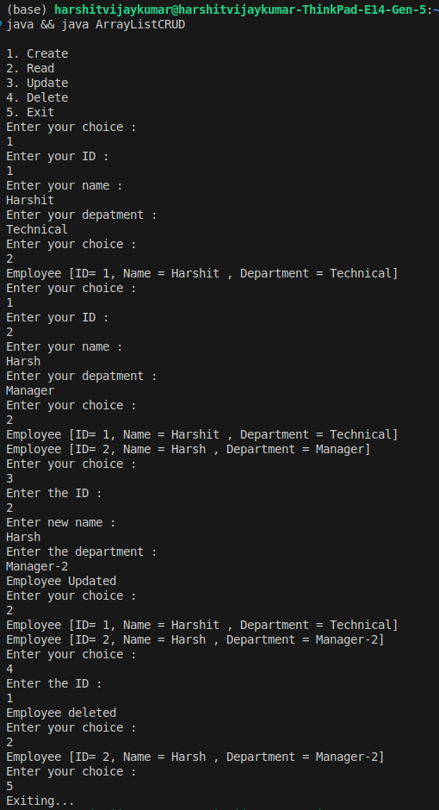

**7) Perform CRUD operation using JDBC in an EmployeeJDBC class for the below Employee**

**class Employee{**

**private int id;**

**private String name;**

**private String department;**

**}**

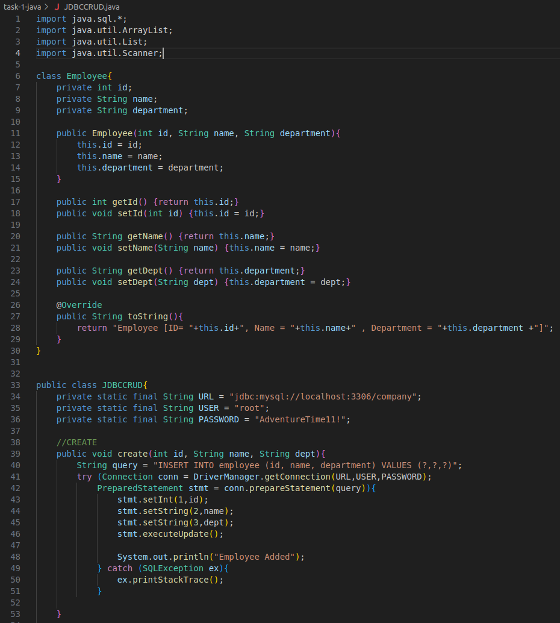

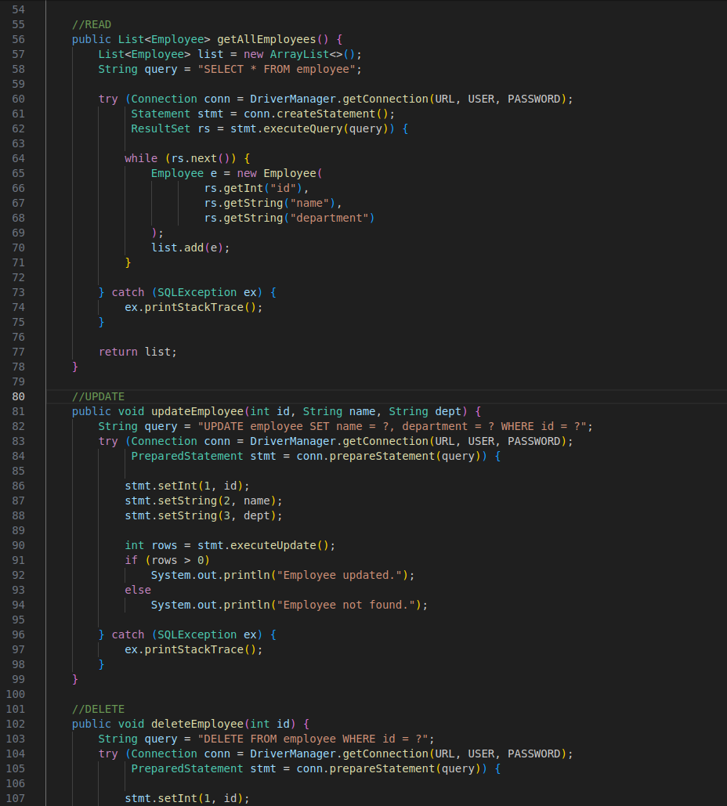

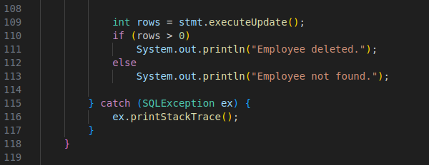

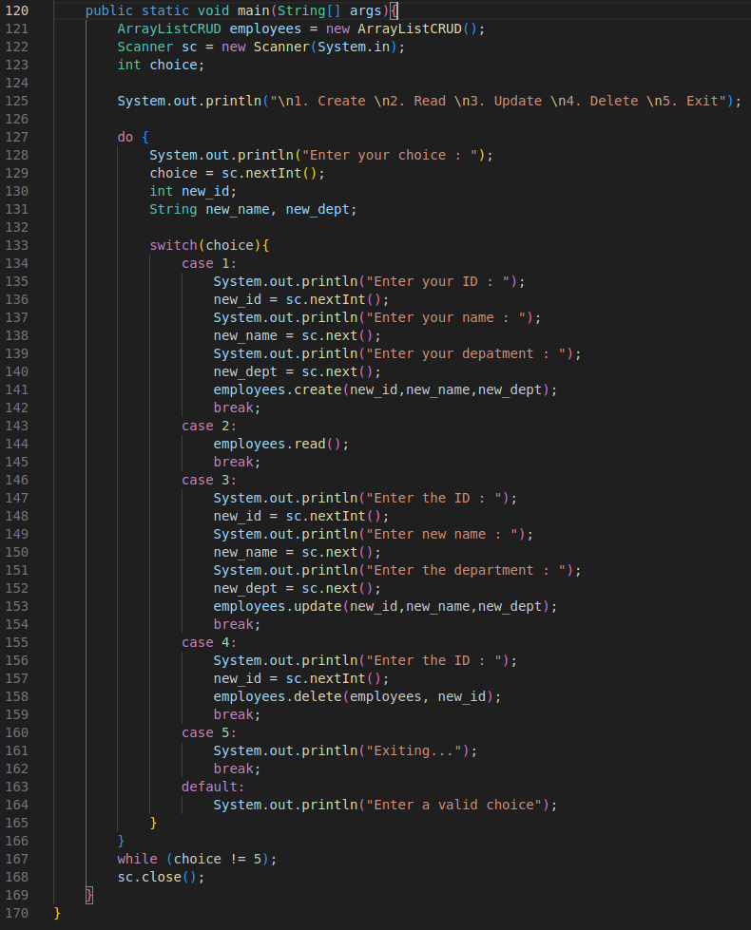

**Output –**

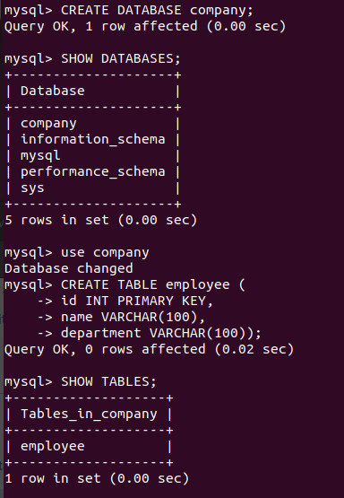

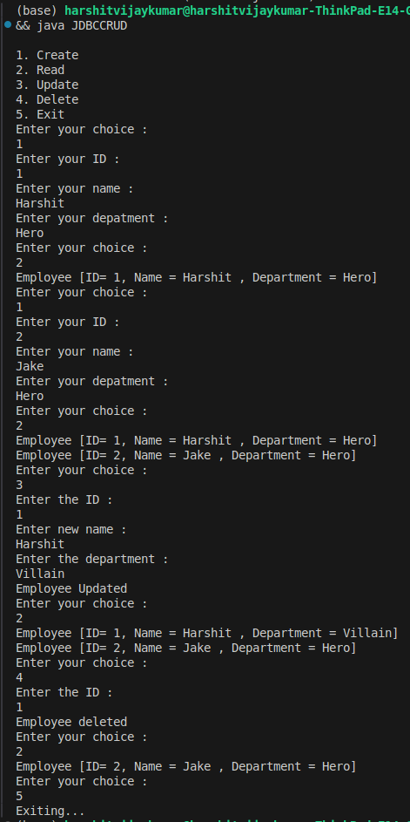

**JavaScript Assignment**

